Lab 7 Exception Handling

Exercise 1
Question: Read two integers with Scanner; handle non-numeric input and division by zero.
Java source code:
import java.util.*;

public class Exercise1SafeDivision {

public static void main(String[] args) {
try (Scanner scanner = new Scanner(System.in)) {
// Prompt the user for two integers and perform division
System.out.print("Enter the dividend: ");
int dividend = scanner.nextInt();
System.out.print("Enter the divisor: ");
int divisor = scanner.nextInt();
// Perform the division and print the result
System.out.println("Result: " + (dividend / divisor));
// Catch exceptions for invalid input and division by zero
} catch (InputMismatchException e) {
System.out.println("Please enter integers only");
} catch (ArithmeticException e) {
// Integer division by zero is reported separately from invalid input.
System.out.println("Cannot divide by zero");
}
}
}

Expected output (sample):
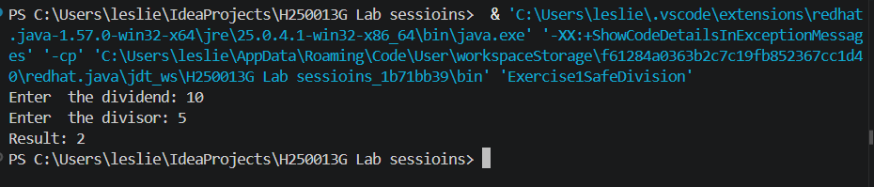
Enter two integers: Please enter integers only
Explanation: InputMismatchException handles non-integer input. ArithmeticException handles division by zero.

Exercise 2
Question: Access an array element and catch ArrayIndexOutOfBoundsException.
Java source code:
public class Exercise2ArrayAccess {
static void printElement(int[] values, int index) {
try {
// Attempt to access the array element at the specified index
System.out.println(values[index]);
} catch (ArrayIndexOutOfBoundsException e) {
System.out.println("Invalid array index");
}
}

public static void main(String[] args) {
int[] values = {10, 20, 30};
// The second call demonstrates how an invalid index is handled.
printElement(values, 1);
printElement(values, 5);
}
}

Expected output (sample):
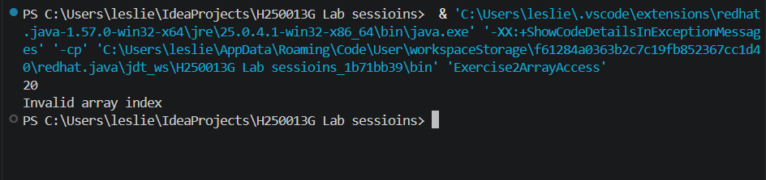Explanation: The try block accesses the requested index. The catch block handles an index outside the array.

Exercise 3
Question: Create checked InvalidAgeException and validate ages 0–120.
Java source code:
class InvalidAgeException extends Exception {
InvalidAgeException(String message) {
super(message);
}
}

public class Exercise3InvalidAge {
static void validateAge(int age) throws InvalidAgeException {
// Check if the age is within the valid range
if (age < 0 || age > 120) {
throw new InvalidAgeException("Age must be between 0 and 120");
}
}

public static void main(String[] args) {
try {
validateAge(150);
} catch (InvalidAgeException e) {
// The custom exception carries the validation message.
System.out.println(e.getMessage());
}
}
}

Expected output (sample):
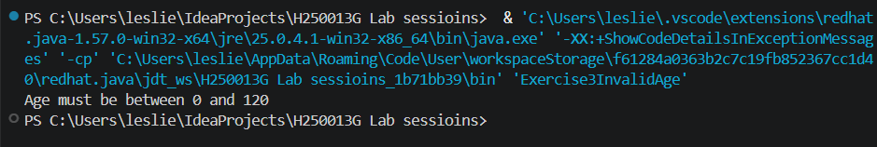Explanation: Extending Exception creates a checked exception. The method declares throws and the caller catches it.

Exercise 4
Question: Make withdraw throw InsufficientFundsException rather than return false.
Java source code:
public class Exercise4WithdrawException {
static class InsufficientFundsException extends Exception { InsufficientFundsException(String message){super(message);} }
static class BankAccount { double balance; BankAccount(double b){balance=b;} void withdraw(double amount) throws InsufficientFundsException { if(amount>balance) throw new InsufficientFundsException("Insufficient funds"); balance-=amount; } }
public static void main(String[] args) { BankAccount a=new BankAccount(100); try { a.withdraw(150); } catch(InsufficientFundsException e) { System.out.println(e.getMessage()); } System.out.println("Balance: "+a.balance); }
}
Expected output (sample):
Insufficient funds
Balance: 100.0
Explanation: An exception gives the caller a clear reason for failure. A boolean return is simpler but carries less detail.

Exercise 5
Question: Predict a return in try with a print statement in finally.
Java source code:
public class Exercise5FinallyReturn {
static int example() { try { System.out.println("Inside try"); return 5; } finally { System.out.println("Inside finally"); } }
public static void main(String[] args) { System.out.println("Returned: "+example()); }
}
Expected output (sample):
Inside try
Inside finally
Returned: 5
Explanation: finally executes before the method returns, so its message prints before the caller prints the returned value.

How to run
Open the Java_Files folder in IntelliJ IDEA. Open the exercise file and run its main() method. Alternatively, open a terminal in Java_Files and run: javac ExerciseFile.java, then java ExerciseClassName. JDK 17 or later is recommended.

